Co-Chair  Vernon Sykes, Representative  34th House District | 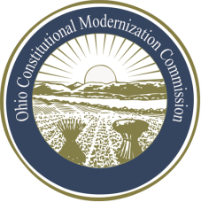 | Co-Chair  William G. Batchelder, Speaker  69th House District
Ohio Constitutional Modernization Commission

Legislative & Executive Committee
Fred Mills, Chair
Thursday, August 8, 2013

Chairman Miller called the meeting of the Ohio Constitutional Modernization Commission, Legislative and Executive Committee to order at 9:05 A.M. A quorum was present. The minutes from the previous meeting were read and approved.

The Chairman introduced Ann Henkener of the League of Woman Voters of Ohio to present testimony regarding redistricting in Ohio and the effects of gerrymandering. Ms. Henkener argued for a set of standards that would result in competitive districts and fair representation.

The Ohio State University Professor Emeritus, Richard Gunther, also gave testimony regarding gerrymandering and the benefits of competitive districts.

Both presenters agreed that Ohio’s districts should be representative of its population, stating that because of equal opportunity gerrymandering, districts in Ohio were not being fairly represented.

Representative Sykes offered an outline of his plan which included a competition decided by a mathematical process. This competition would be open to the public. Representative Sykes closed by saying that any plan should be chosen by a unanimous vote.

With no further business before the committee, Chairman Mills adjourned at approximately 10:20 P.M.

